EXPERIMENT 13
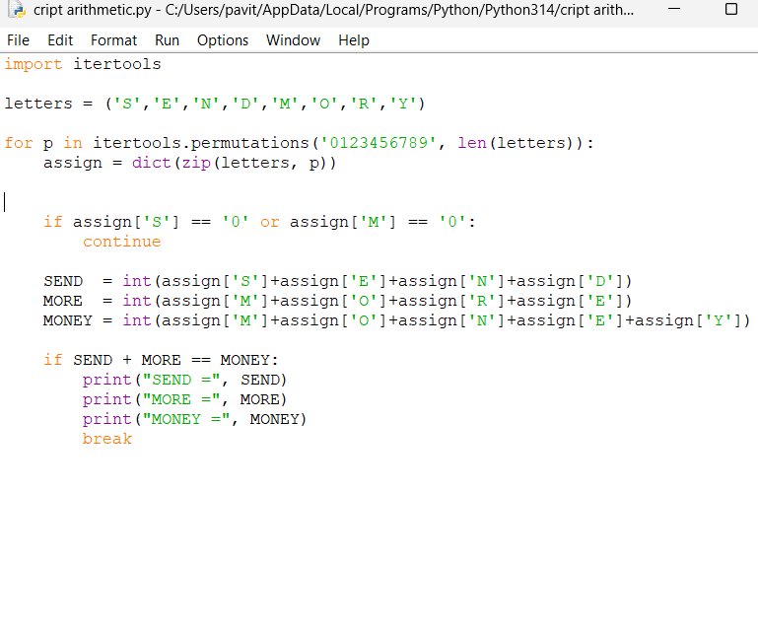
OUTPUT

